Name: Mohamed Haneefa Jiyavudeen

Tutorial group: T03F

UOW number: 8496407

Assignment 3 (Problem Solving)

Question 1)

|  |  |
| --- | --- |
| Shortest Length | Length |
| E | 0 |
| E,B | 5 |
| E,C | 7 |
| E,D | 7 |
| E,B,A | 5+2=7 |
| E,B,A,F | 5+2+3=10 |

**SPT**

(7)

7

F

C

C

A

D

E

7

(7)

(10)

3

5

2

(5)

(7)

Question 2)

Starting from vertex C, Minimum Spanning Tree can be formed by selecting the following edges:

(C, D), (C, B), (B, A), (A, F), (B, E)

The minimum total weight = 2 + 3 + 2 + 3 + 5 = 15

Question 3)

Initial UB = 10 + 4 + 4 + 7 = 25, initial LB = 5 + 4 + 2 + 3 = 14 (lowest per row)

UB = ~~25~~ ~~20~~ 15 0

Start

LB = 5+4+2+3+14

C-> 4, D-> 1

Lb = 5+4+3+3 = 15

C->1, D->4

Lb = 5+4+4+7 = 20

B -> 4

Lb = 5+7+2+3 = 17

B -> 2

Lb = 5+4+3+3 = 15

B -> 1

Lb = 5+5+2+5 = 17

A -> 1

LB=10+4+2+3=19

A -> 4

LB=6+4+2+3=15

A -> 3

LB=5+4+2+3=14

A -> 2

LB=6+5+3+3=17

1 2 3 4

*(LB>UB (15))

*C->4 so eliminate

*(LB>UB (15))

5 6 7

*(LB>UB (15))

*(LB>UB (15))

8 9

*(LB>UB (15))

There is only 1 solution to this case where

* A is assigned to Job 3
* B is assigned to Job 2
* C is assigned to Job 4
* D is assigned to Job 1

|  |  |  |  |  |
| --- | --- | --- | --- | --- |
|  |  |  |  |  |
|  |  |  |  |  |
|  |  |  |  |  |
|  |  |  |  |  |
|  |  |  |  |  |

Question 4) 0

|  |  |  |  |  |
| --- | --- | --- | --- | --- |
| Q |  |  |  |  |
|  |  |  |  |  |
|  |  |  |  |  |
|  |  |  |  |  |
|  |  |  |  |  |

1

|  |  |  |  |  |
| --- | --- | --- | --- | --- |
| Q |  |  |  |  |
|  |  |  |  |  |
|  | Q |  |  |  |
|  |  |  |  |  |
|  |  |  |  |  |

2

|  |  |  |  |  |
| --- | --- | --- | --- | --- |
| Q |  |  |  |  |
|  |  |  |  |  |
|  | Q |  |  |  |
|  |  |  |  |  |
|  |  | Q |  |  |

3

|  |  |  |  |  |
| --- | --- | --- | --- | --- |
| Q |  |  |  |  |
|  |  |  | Q |  |
|  | Q |  |  |  |
|  |  |  |  |  |
|  |  | Q |  |  |

4

|  |  |  |  |  |
| --- | --- | --- | --- | --- |
| Q |  |  |  |  |
|  |  |  | Q |  |
|  | Q |  |  |  |
|  |  |  |  | Q |
|  |  | Q |  |  |

5

Question 5)

a)

b)i)

25 deleted

b)ii)

38 deleted

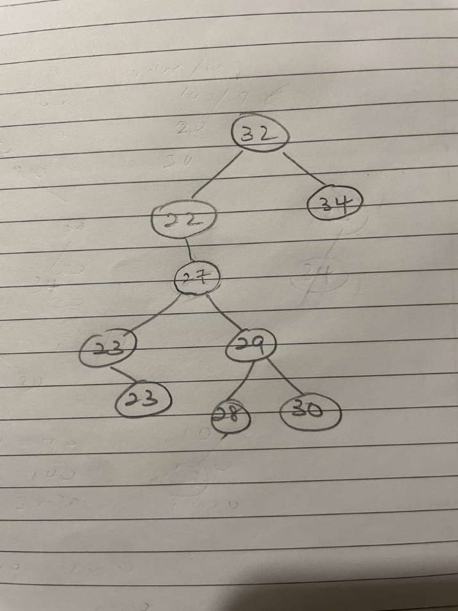

Question 6)

Minimum spanning tree can be formed using these edges:

(f, e), (f, b), (c, d), (f, g), (g, a), (b, c), (e, h)

The minimum total weight = 5 + 6 + 7 + 7 + 8 + 9 + 9 = 51

Rest are voided as it may create a cycle and we also have achieved v-1 edges where v is the total number of edges.

Question 7)

Vertices are visited in this order

16, 12, 8, 3, 2, 1, 5, 6, 7, 11, 14, 10, 9, 13, 15, 4